**Software Requirements**

**Specification**

**Pharmacy Management System**

**Date Created: November 30, 2023**

# Introduction

## Purpose

This Software Requirement Specification outlines the requirements for the Pharmacy Management System. It defines the scope of the system, covering the features and functionalities necessary for optimized and managed pharmacy operations. The system shall cater to the needs of all the requirements which can be encountered in pharmacy stores. This Software Requirement Specification

(SRS) document may cover the entire features offered by the Pharmacy Management System (PMS).

## Document Conventions

The Following conventions are followed in this SRS document:

* **Fonts:** Bold Fonts are used mainly for the headings and subheadings, specially used to highlight an important point. Regular Font is used for general text.
* **Highlighting:** Important key points or notes and references are highlighted for emphasis.
* **Lists:** Bullet Points are used for the listing of items. Sequenced numbering is also used for the listing of Items in the SRS document.

## Intended Audience and Reading Suggestions

The document is intended for various types of readers including:

* Software Developers.
* Project Managers.
* System Testers.
* System Stakeholders.
* Documentation Writers.

The reading sequence is suggested as follows:

* Sections are Overviews for high-level understanding of the system.
* Sections are partitioned to developers for detailed technical analysis.
* Sections for Project Managers to understand project scope and track the project timeline.
* Pharmacists can focus on sections related to the system’s functional requirement and user interactions.
* Documentation writers can focus sections related to user manual and document Glossary.

## Product Scope

The Pharmacy Management System is designed to cater to the needs of everyday Pharmacy operations, including inventory management, prescription processing, and managing customer interactions. The main goal of the system is to improve the efficiency, accuracy and customer service within the pharmacy store. The system provides the goals of precision and accuracy in medication dispensing, managing the inventory, and enhancing the overall pharmaceutical operations smoothly.

## References

The following documents and references are relevant to this Software Requirement Specification (SRS) document:

* Pharmacy Standards and Regulations.
* User Interface Design Standards.
* Privacy And Security of Inventory and User data.
* Use Case documents defining the user-system interactions.

# Overall Description

## Product Perspective

The Pharmacy Management System is a self-contained product designed to improve, enhance and provide efficient pharmacy operations. This proposed system is not an existing product family, but it is developed as a standalone system for pharmaceutical operations. The system interface may use external entities or components such as SQL database for inventory management activities, an external printing device for prescription and Billing activities.

## Product Functions

The Pharmacy Management System is designed to perform the following major functions:

* Prescription processing and management
* Inventory tracking and management
* Drug interaction checking
* Sales and billing
* Reporting and analytics

## User Classes and Characteristics

The Pharmacy Management System includes the following User Classes:

### Administrator/Pharmacists:

The Pharmacist has the following characteristics in regard to the Pharmacy Management System:

• Access and Manage all data.

## Operating Environment

### Hardware Platform:

The Pharmacy Management System will require the following hardware platform to be smoothly operated:

* At least 4GB RAM.
* 4-core Microprocessor.
* Printing Device for Prescription.

### Operating System:

The Pharmacy Management System will require the following Operating System to be smoothly operated:

* At least Windows 7.
* Mac OS.

## Design and Implementation Constraints

### Regulatory Policies:

* The Pharmacy Management System should support and comply with the regulations related to electronic prescribing to ensure its secure transmission.
* Compliance with general data protection laws is essential, which includes protection of patient privacy, secure data transmission, and secure storage of sensitive drug information. • The system should align with the jurisdictions imposed by the respected Pharmacy regulatory authorities.

### Hardware Limitations:

* The Pharmacy Management System should utilize the hardware resources in an optimized approach.
* The maximum processing speed of the system for a particular action should be under 4 seconds.
* The system should respond to the user actions within a minimum of 3 seconds.
* The Pharmacy Management system shall utilize the memory space of the computer efficiently.
* The system shall ensure that crucial operations are performed in an optimal approach without wasting any memory space.

## User Documentation

The user documentation of the proposed Pharmacy Management System will include:

* User Manuals for pharmacist, pharmacy technicians, and administrative staff.
* Necessary Guide as online help resources shall be integrated into the proposed system.
* Error prevention and error mitigation steps.
* Steps on How to install and get started with the system.
* Tutorials for everyday tasks and system functionalities.

## Assumptions and Dependencies

### Assumptions:

The following assumptions will be made for the efficient use of the Pharmacy Management System: • The availability of all input and output devices to easily interact with the system.

* The availability of all required hardware and software requirements for the use of the proposed system.
* Aligning of the system with all essential pharmacy regulations imposed by the related Law enforcing authorities.
* Basic knowledge of the Pharmacist/end-user on how to interact with the system.
* The accuracy of the data entered the system, including drug information, its type, price and other related information.

### Dependencies:

The following dependencies for the efficient use of the Pharmacy Management System:

* Proper integration with third-party entities such as MySQL, for real-time inventory Management.
* Application of a specific Database Management system (MySQL) for the proposed system.
* The successful operation of the also depends upon the adequate usage of the pharmacy staff.

# External Interface Requirements

## User Interfaces

*Logical Characteristics:*

* The user interface of the proposed Pharmacy Management System is designed using Java Swing AWT classes for a consistent, user-friendly and platform-independent interface.

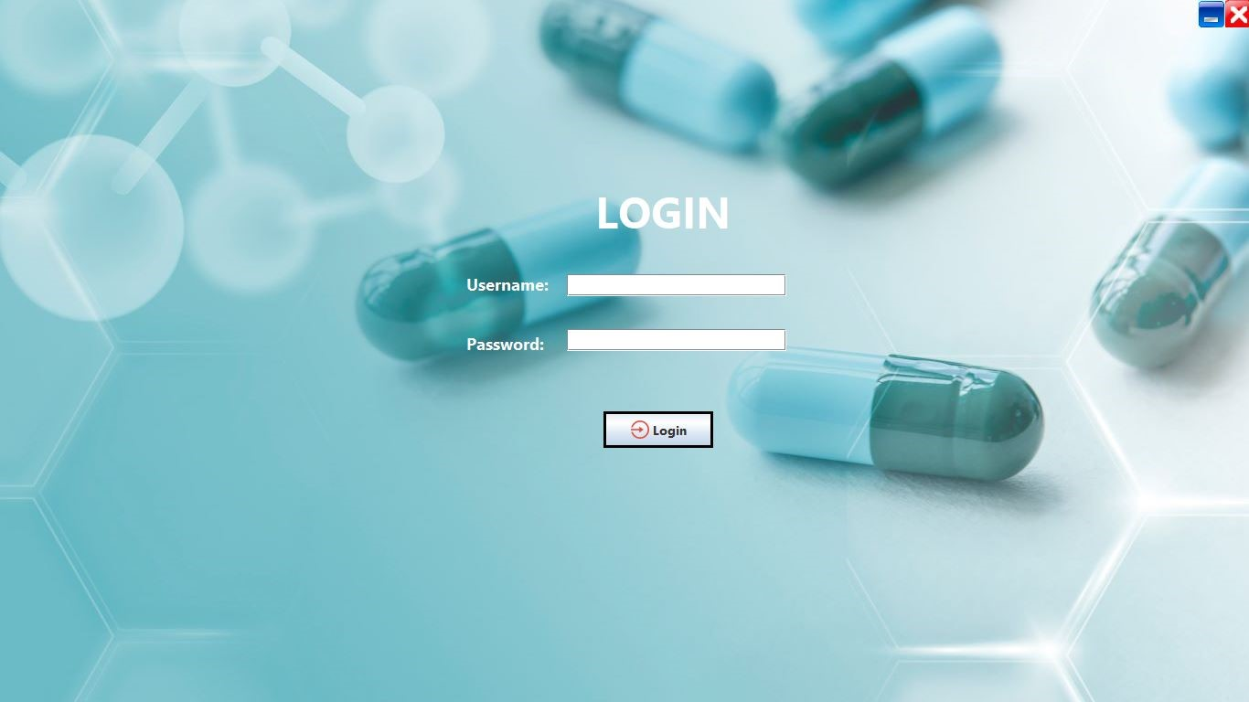

* GUI standards and product interface are designed mainly based on Human Computer Interaction guidelines.

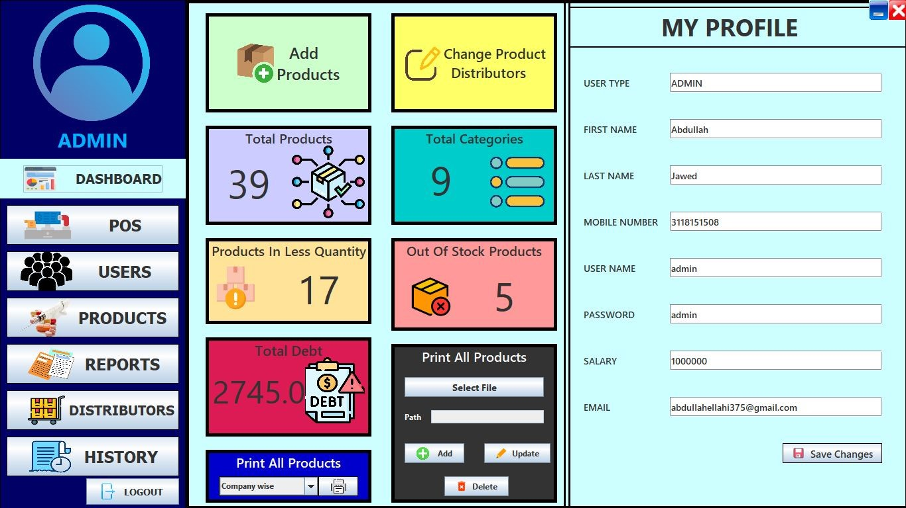

Standard buttons and functions for user actions are specified consistently in every screen of the system for an effective and cohesive look and feel for the users.

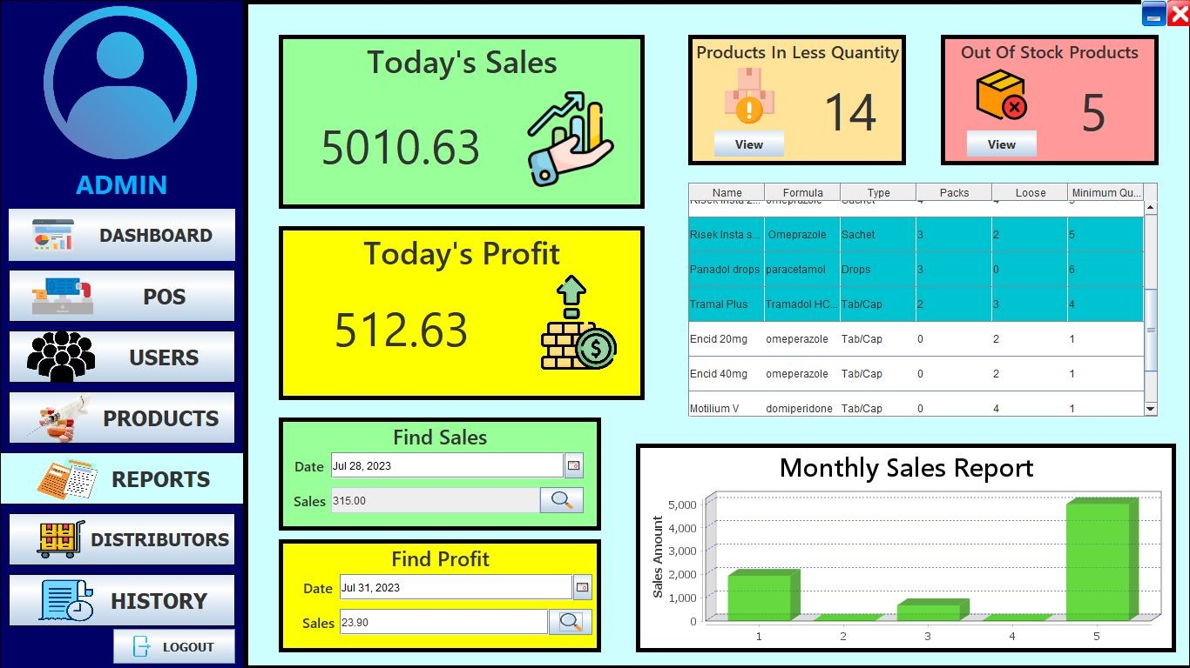

* In case of any error occurrence, relevant error messages are displayed using dialogue boxes for effective user feedback and convenience.

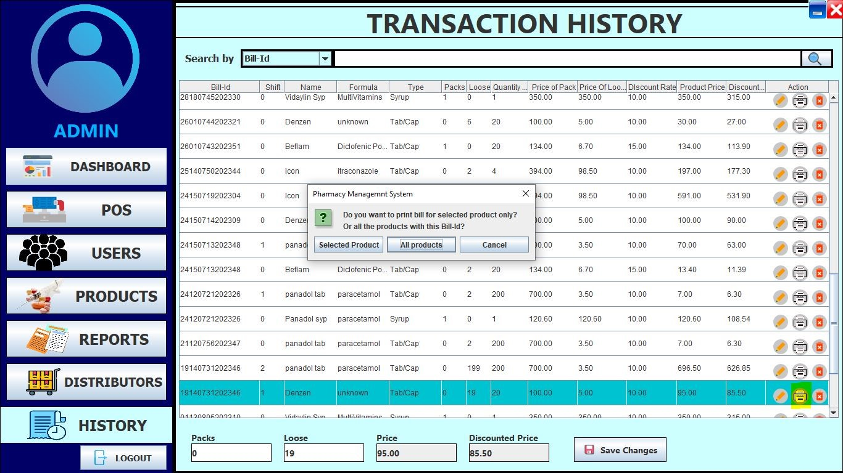

Graphs have been used to show daily and monthly sales profit for an accurate data analysis.

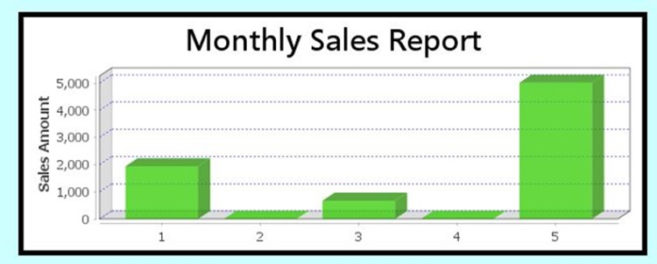

* Separate interfaces to show daily Profits, debt, sales and overall product availability for a detailed analysis.

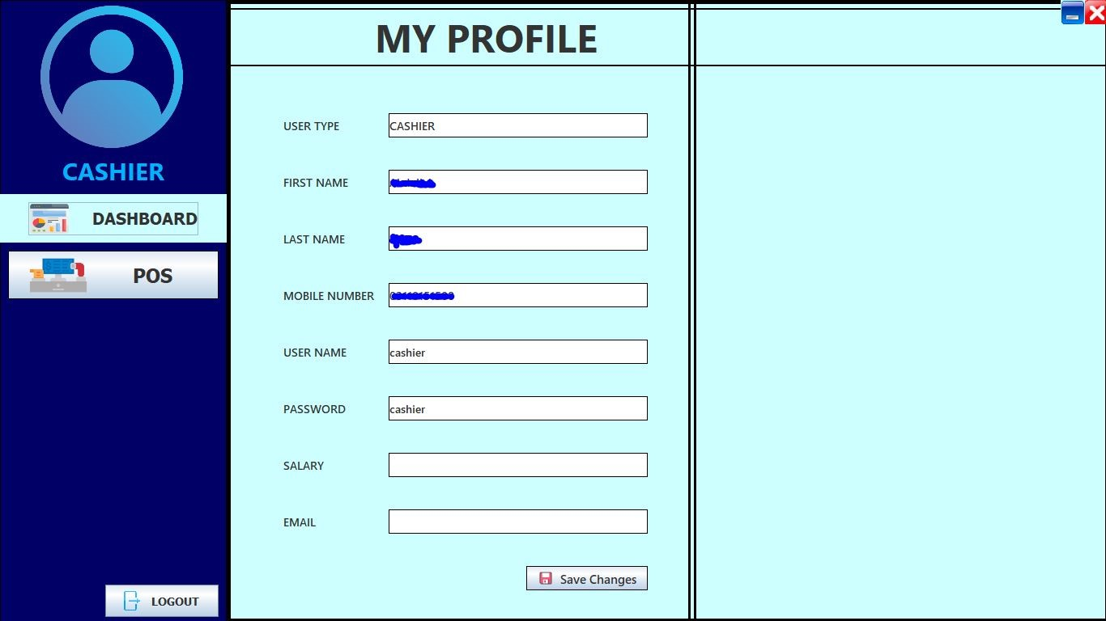

User friendly interfaces to add and edit products according to the product type, with the company names.

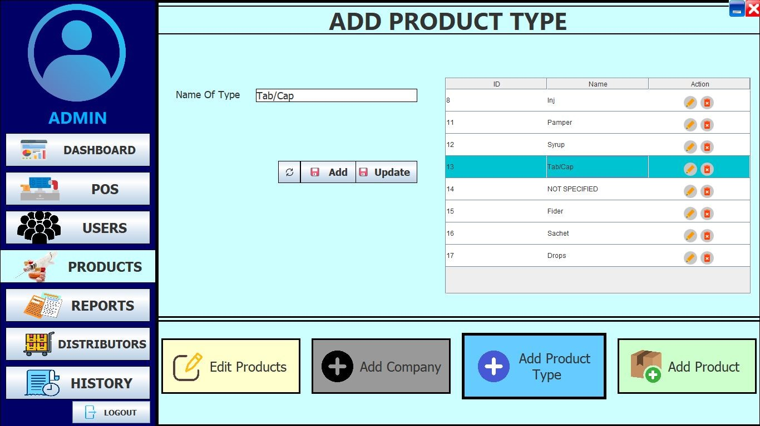

* Separate UI interface to add distributors along with their name, company and personal information.

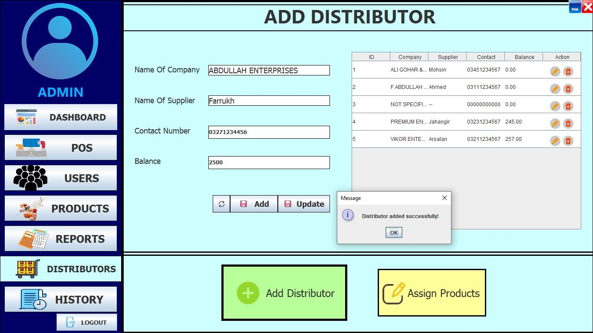

And finally, the successful Sales Receipt Generation upon completion of each transaction is printed with all the necessary details of the medicines purchased by the customer.

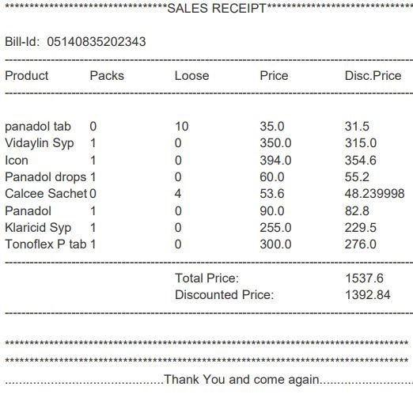

## Hardware Interfaces

*Logical Characteristics and Physical Characteristics:*

* **Supported Hardware:** The Pharmacy Management system supports standard pharmacy computing Hardwares, including all desktop computers.
* **Data Control Interactions:** Data transmission and control between the Software and hardware components will be handled precisely and accurately without any error.
* **Communication Protocols:** The system shall specify communication protocols with the relevant database to ensure compatibility with the supported hardware devices.
* **Supported Device Types:** The system shall support a variety of device types commonly used in pharmacy stores, including all but not limited to desktop computers, laptops, tablets, barcode scanners, and receipt printers.

## Software Interfaces

*Connections with Other Software Components:*

* **Java Swing AWT Classes:** The user interfaces are designed using Java Swing AWT Classes to ensure a responsive, user-friendly and platform-independent graphical interface.
* **Database Connection:** The system shall establish connections with MySQL Database Management System for efficient data storage and retrieval.
* **Data Sharing Mechanism:** The system shall share data across the MySQL database.
* **Mechanism for Data Sharing:** By using MySQL queries for data storage, retrieval and manipulation.

## Communications Interfaces

*Communication Functions:*

* **Data Transfer Protocols:** The Pharmacy Management system uses standard data transfer protocols for communication with the MySQL database.
* **SQL Query Format:** SQL queries sent to MySQL database follow the standard SQL language standards.
* **System-generated Queries:** The system generates queries on run-time based on the user actions and then the system processes to interact with the database for actions such as data insertion, retrieval, and manipulations.
* **Database Connection Security:** Communication between the system and the MySQL database server is secured using encryption protocols (e.g., TLS/SSL).
* **Encryption Ensures:** Confidentiality, privacy, and integrity of data related to the database connection.
* **Query Optimization Techniques:** The system manages query optimization techniques to improve the accuracy and precision of SQL queries.
* **Techniques Include:** Indexing, planning query analysis, and appropriate use of MySQL query storage managers.

# System Features

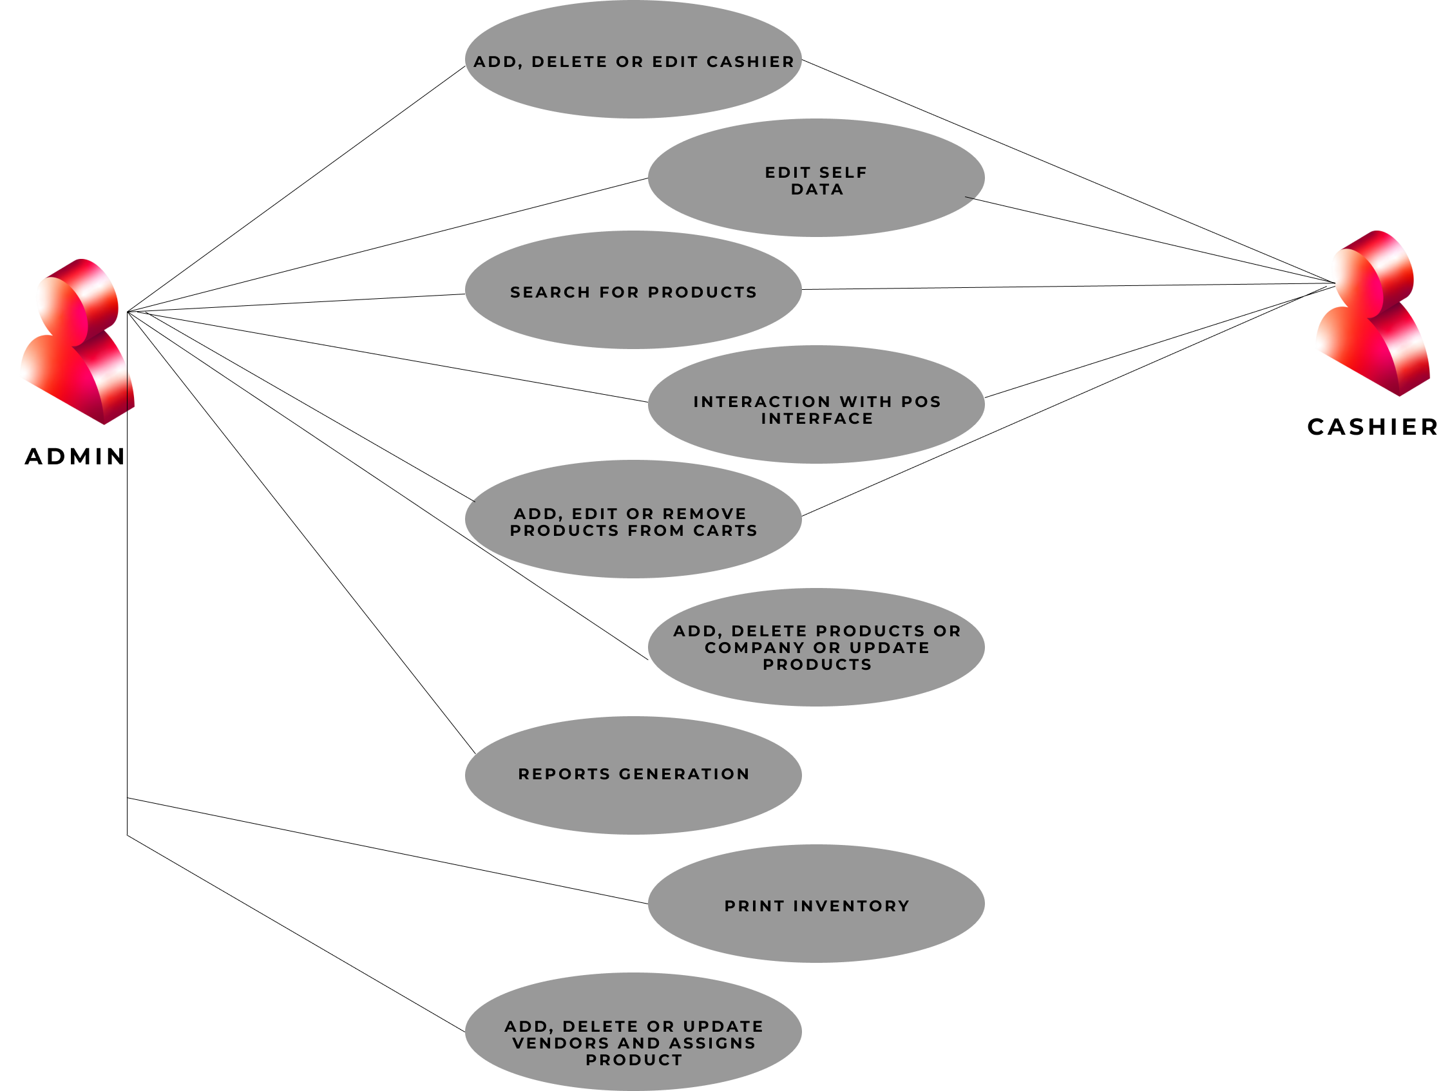

Figure 1: **Use case**

## User Management:

*Description and Priority:*

Two types of users:

* Admin: He can add, delete, or edit cashiers except himself and has full accessibility.
* Cashier: He can only edit his data and has accessibility to the Point of Sale.

This feature has high priority due to its critical role in system security and access control.

*Stimulus/Response Sequences:*

* Admin can add a new cashier, delete an existing cashier and edit cashier details.
* Cashier can edit his own information and can access POS.

*Functional Requirements:*

1. REQ-01: Admin should have a dedicated interface to manage cashiers. The system shall allowhim to add, delete, or edit cashier accounts.
2. REQ-02: Cashiers should have a separate interface with limited privileges.
3. REQ-03: To ensure security authentication and authorization mechanisms will be present.

## Search Bar:

*Description and Priority:*

Users should be able to search products by various aspects, which includes product name, formula, type, company, and discount rate.

Priority is medium as this feature is for enhancing user experience.

*Stimulus/Response Sequences:*

* User will enter a query for search.
* System will display search results.

*Functional Requirements:*

1. REQ-04: Search bar functionality should be available on relevant pages.
2. REQ-05: Products should be searchable by name, formula, type, company, and discount rate.

## Point of Sale:

*Description and Priority:*

This module is for managing transactions. Priority is high as this is for core business functionality.

*Stimulus/Response Sequences:*

* User will interact with the POS interface.
* System will update cart, calculate prices, and generate receipts.

*Functional Requirements:*

1. REQ-06: Integrate the search bar for quick product lookup at POS interface.
2. REQ-07: Support cart management, quantity editing, and discount application.
3. REQ-08: Provide a print receipt functionality.

## Carts:

*Description and Priority:*

There should be two carts for managing two customers simultaneously and the quantity of products added in the cart should be editable. Carts should generate individual product prices, discount prices, overall total, and discounted price and also both carts should have print receipt functionality. High priority for streamlining customer transactions.

*Stimulus/Response Sequences:*

* Admin/Cashier will add, edit, or remove products from carts.
* System will update cart information and calculate prices.

*Functional Requirements:*

1. REQ-09: The system should support two simultaneous carts.
2. REQ-10: Users should be able to edit the quantity of products as per his need in the cart.
3. REQ-11: The system should generate individual product prices, discount prices, overall total,and discounted price for each cart.

## Products Management/Inventory:

*Description and Priority:*

Comprehensive product management with fields such as ID, name, formula etc and all fields will editable and also companies and types of products can be added or deleted. Inventory will printable alphabetically and by company.

Priority is high for maintaining accurate stock information..

*Stimulus/Response Sequences:*

* Admin will add, delete, or update products and also add or delete a company.
* System will update the product and company database and inventory records.
* Admin will print inventory in alphabetical and company-wise order.

*Functional Requirements:*

1. REQ-12: Product details include ID, name, formula, type, company, packs, loose, etc.
2. REQ-13: Admin can add, delete, and update products.
3. REQ-14: All product fields are editable.
4. REQ-15: Inventory is printable in alphabetical and company-wise order.

## Reports:

*Description and Priority:*

The system will generate various reports, including daily sales, daily profit, and monthly reports(in bar graph). It will also provide sales and profit for any previous date. Products which are in less quantity or out of stock will be displayed.

Priority is medium for analyzing sales and inventory.

*Stimulus/Response Sequences:*

* User will select report type and date range.
* System will generate and display reports.

*Functional Requirements:*

1. REQ-16: Implement report generation functionality.
2. REQ-17: Generate daily sales and profit reports and also monthly reports(It will include bargraph).
3. REQ-18: Provide sales and profit information for any previous date.

## Vendor/Distributor Management:

*Description and Priority:*

Admins can add, delete, and edit vendors. A separate module will be available for assigning products to vendors.

Priority is medium for efficient inventory and order management.

*Stimulus/Response Sequences:*

* Admin will add, delete, or update vendors and assigns products.
* System will update vendor and product records.

*Functional Requirements:*

1. REQ-19: Vendors can be added, deleted, or edited.
2. REQ-20: There should be a module for assigning products to vendors.
3. REQ-21: For inventory and ordering, products can be categorized by vendors.

## Transaction History:

*Description and Priority:*

System will track product refunds, allow printing old transactions, and support partial product refunds.

Priority is high for customer service and record-keeping.

*Stimulus/Response Sequences:*

* User will request old transactions or initiate a refund.
* System will retrieve or process the requested transaction.

*Functional Requirements:*

1. REQ-22: Refund functionality for products in previous transactions.
2. REQ-23: Old transactions and receipts will be printable.
3. REQ-24: Transactions will be searchable by bill ID, product name, formula, type, and discountrate.
4. REQ-20: Cashier will be able to refund one or all products from a transaction.

# Other Nonfunctional Requirements

## Performance Requirements

*Response Time:*

The system should respond to user requests within one second under normal load conditions. Search operations, including product searches, should return results within 3 seconds.

*Concurrency:*

The system should support concurrent access by up to 1000 users without significant degradation of performance.

*Data Import/Export:*

Bulk data imports or exports i.e. via Excel/CSV files) should be completed within 5 minutes when records of dataset is within 1000.

**Rationale:**

To ensure that the system can handle the expected workload and provide fast and reliable service to the users. For providing a seamless user experience and handling simultaneous operations, this is crucial.

## Safety Requirements

*Data Encryption:*

The system should encrypt all sensitive data, such as user information, prescription details, and payment transactions.

*User Authentication and Access Control:*

Authentication of the users is mandatory before granting them access to the system and to limit their privileges according to their functions, enforced role-based access control policies.

*Regulatory Compliance:*

The system should comply with the relevant laws and regulations regarding the privacy and security of health information.

*Audit Trials:*

To provide audit trails for accountability and traceability, the system should log all user activities and system events.

**Rationale:**

To ensure the confidentiality, integrity, and availability of the data and to protect the rights and interests of the users.

## Software Quality Attributes

*Maintainability:*

The system should be feasible to maintain by following clear and consistent coding standards and documentation practices and for testing and debugging, provide tools and mechanisms.

*Usability:*

The system should be easy to use and learn by providing a simple and user friendly interface and navigation, helpful feedback and guidance, consistent and familiar conventions and terminology.

*Availability:*

The system should be available for use at all times i.e. when there is no scheduled maintenance or any unexpected circumstances occur.

*Interoperability:*

By using standard protocols and formats, the system should be able to communicate and exchange data with other systems and applications, like that electronic health records, insurance providers and suppliers.

*Reusability:*

To reduce development time and cost and to increase level of consistency and quality, the system should use modular and reusable components and libraries.

**Rationale:**

To ensure that the system meets the needs and expectations of the users and the stakeholders and gives a high-quality product and service.

Software quality attributes define characteristics that are necessary for the success of the system.

## Business Rules

*Role-Based Actions:*

User management actions such as adding, deleting, or editing cashiers can be performed by only administrators. Cashiers have not be able to edit their data and accessing the Point of Sale (POS) module.

*Tracking Inventory*

The system and the users must keep track of the inventory and supply of the drugs and place order for new stocks when needed.

**Rationale:**

Under specific circumstances how the system should operate and to ensure that the system and the users comply with the legal and ethical standards and practices of the pharm industry.

# Other Requirements

## Regulatory Compliance

* The system should ensure compliance with all the national and international laws imposed to regulate the privacy and security of the Pharmacy Management System and its related operations.
* The system shall implement all the necessary features to comply with the laws to ensure the best healthcare practices.

## Performance Requirements

* The system should be able to handle an increasing number of medication inventory and database user load without any error occurrence.
* The system shall increase performance efficiency through database indexing.

## Database Requirements

* The system shall have regular data backup plans for MySQL Database.
* The mechanism for quick data recovery shall be implemented in case of any system/data failure.
* Proper data entry validations should be implemented to ensure the data integrity in the database schema.
* Transactions should be implemented to maintain consistency during complicated database operations.

# Appendix A: Glossary

|  |  |
| --- | --- |
| Term | Definition |
| Product | All items (including medications, accessories, and health products) which are available in the pharmacy for sale. |
| POS | Point of Sale system used for processing transactions, managing inventory, and generating receipts. |
| Vendor | A supplier or distributor of products to pharmacy. |
| Transaction | An instance of a purchase or sale, with its details such as items, quantities, and prices, recorded in the system. |
| Inventory | In this there is a complete list of products available in the pharmacy, along with their quantities and details. |
| Refund | The process of returning products and reimbursing the customer’s payment. |

# Appendix B: Analysis Models

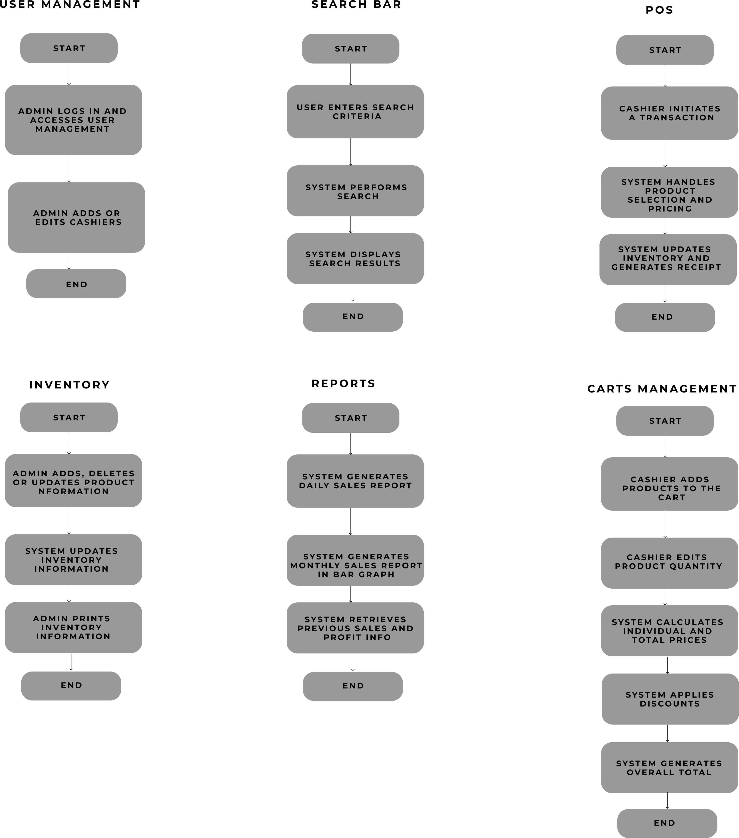

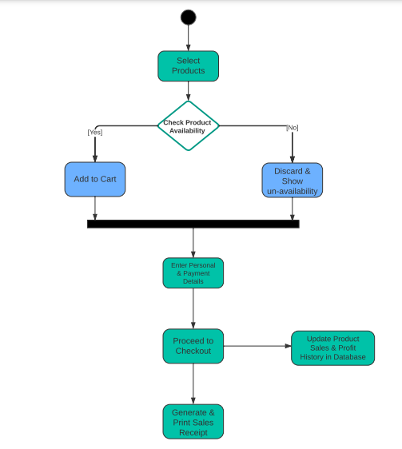

# Appendix C: To Be Determined List

|  |  |
| --- | --- |
| System Security Measures: | Details about the specific security measures, authentication methods, and encryption protocols to be implemented are yet to be determined. |
| Additional Reports | The creation and inclusion of additional reports beyond the specified daily sales and profit reports are yet to be determined. |
| Integration With External  System | The specifics of integration with external systems, such as financial software or regulatory databases, are yet to be determined. |
| User Authentication Process | The detailed process for user authentication, including password policies and multi-factor authentication, is yet to be determined. |